### 1. Write a VBA code to enter your name in A1 Cell using Input Box and once you enter the name display a message box that says the name has been entered.

#### Ans:

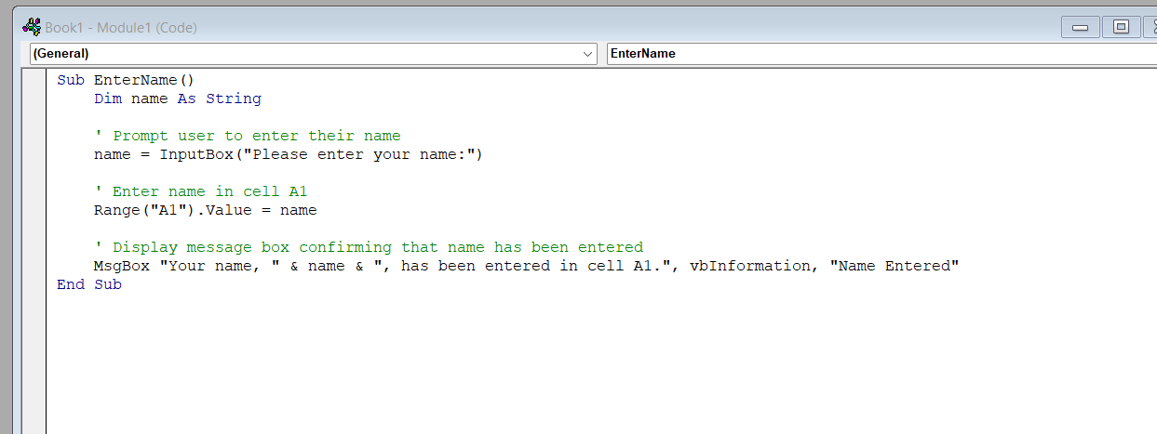

Press f5 to run the code

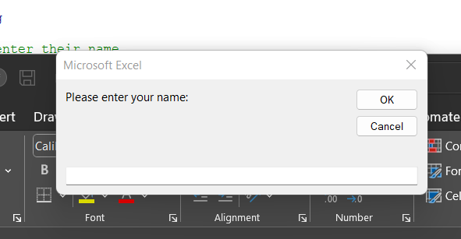

Enter the name in above box

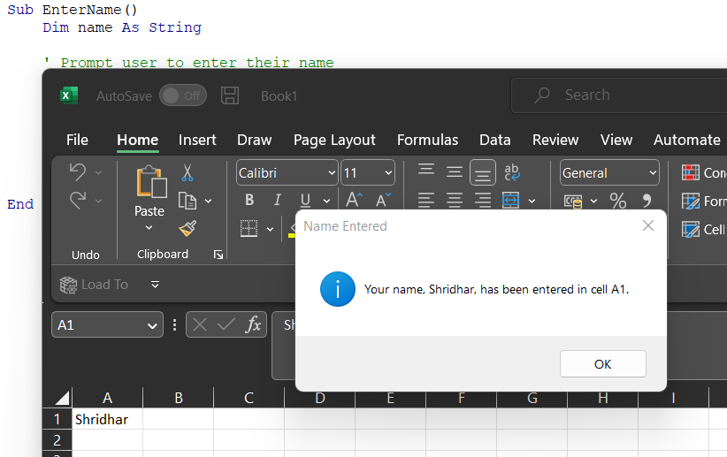

### 2. What are Userforms? Why are they used? How to fill a list box using for loop.

#### Ans:

Userforms are graphical user interfaces that allow users to interact with the Excel workbook through a custom-designed form. They are used to create custom dialog boxes, data entry forms, and other interactive interfaces that are not available through the standard Excel interface.

Userforms are commonly used in Excel VBA to create custom interfaces for data entry, report generation, and other tasks that require user input. They can also be used to create custom dialog boxes that display messages, confirmations, and other information to the user.

To fill a list box using a for loop in Excel VBA, you can use the following code:

' Clear the list box

ListBox1.Clear

' Define an array of values

Dim values(1 To 5) As String

values(1) = "Item 1"

values(2) = "Item 2"

values(3) = "Item 3"

values(4) = "Item 4"

values(5) = "Item 5"

' Loop through the array and add each value to the list box

Dim i As Integer

For i = 1 To 5

ListBox1.AddItem values(i)

Next i

In this code, we first clear the list box using the Clear method. We then define an array of values that we want to add to the list box. In this case, we have created an array of 5 string values.

Next, we use a for loop to loop through the array and add each value to the list box using the AddItem method. The AddItem method takes a single argument, which is the value to add to the list box. In this case, we are adding each value from the array to the list box.

After running this code, the list box will be filled with the values from the array.

### 3. What is an array? Write a VBA code to enter students and their marks from the below table.

#### Ans:

Arrays are a special kind of variable that can store multiple values of the same data type.

For example, if you have the names of 100 employees, then instead of creating 100 variables of data type string, you can just create one array variable of type string and assign 100 values to the same array variable.

* One Dimensional Array

An array that has all the elements in a single row or in a single column is called a One-dimensional array. Listing the names of all the students in the class in a single column is an example of a one-dimensional array. It is declared as shown below.

* Dim arrayname(lowerbound To UpperBound) As DataType

Example:

# 1) Dim MyArrayExample(0 To 3) As Integer

Creates an array with location 0,1,2,3 that will accept Integer values.

# 2) Dim MyArray2(3) As String

Defaults from 0 to 3 and creates an array with location 0,1,2,3 that will accept String values.

# 3) Dim MyArray2(13 to 15) As Double

Creates an array starting from 13 i.e. 13, 14, and 15, and accepts Double values. We have mentioned the lower bound as 13, so the array will start allocating values from location 13 rather than 0.

Consider an example of storing marks of 2 students obtained in 3 subjects. So we will create a 2-dimensional array that takes 2 rows and 3 columns.

We will start the array from row 1 to row 2 and column 1 to column 3.

Sub Twodim()

Dim totalMarks(1 To 2, 1 To 3) As Integer

totalMarks(1, 1) = 23

totalMarks(2, 1) = 34

totalMarks(1, 2) = 33

totalMarks(2, 2) = 55

totalMarks(1, 3) = 45

totalMarks(2, 3) = 44

Msgbox “Total Marks in Row 2 and column 2 is “ &totalMarks(2,2)

Msgbox “Total Marks in Row 1 and column 3 is “ &totalMarks(1,3)

End Sub

Hit F5 or Press the run button on the toolbar to execute the code.

**Row 2 and Column 2** 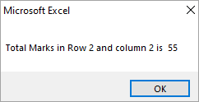

**Row 1 and Column 3** 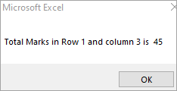

### 5. Check the dataset in the link given below and create a pivot table using VBA showing the sales for the year from stationary category.

<https://docs.google.com/spreadsheets/d/1IRSEnmgz8Ro276-GslknRNk0zlrB5CZH1YrnT71kqFM/edit#gid=846762094>

#### Ans:

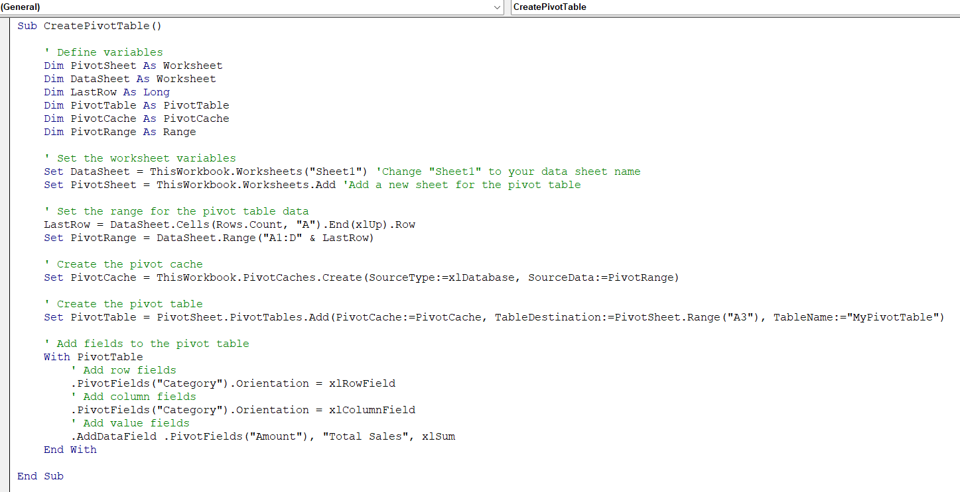

Output:

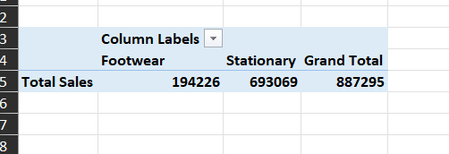

### 6. Write step by step procedure to protect your workbook using a password.

#### Ans:

Here are the step by step procedures to protect your workbook using a password in Excel:

1. Open the workbook that you want to protect with a password.
2. Click on the "File" tab in the Excel ribbon.
3. Click on "Save As" in the left-hand menu.
4. In the "Save As" dialog box, click on the "Tools" drop-down menu and select "General Options".
5. In the "General Options" dialog box, under "File encryption options for this workbook", enter a password in the "Password to open" field. This password will be required to open the workbook.
6. Optional: You can also enter a password in the "Password to modify" field if you want to require a password to make changes to the workbook.
7. Click "OK" to close the "General Options" dialog box.
8. In the "Save As" dialog box, enter a new name for the protected workbook or save it with the same name as the original workbook. Note that the original workbook will not be protected unless you overwrite it with the new protected version.
9. Click "Save" to save the protected workbook.

After you've saved the workbook with a password, you will need to enter the password to open it. If you also added a password to modify, you will need to enter that password to make any changes to the workbook. Keep in mind that if you forget the password, you will not be able to open or modify the workbook unless you use third-party software to remove the password protection.